Create three tables named as Bank, Account holder and Loan table.

Table created for bank:-

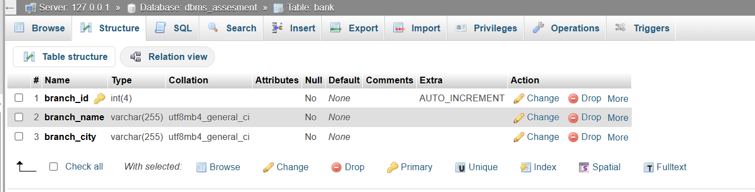

Table created for account holder:-

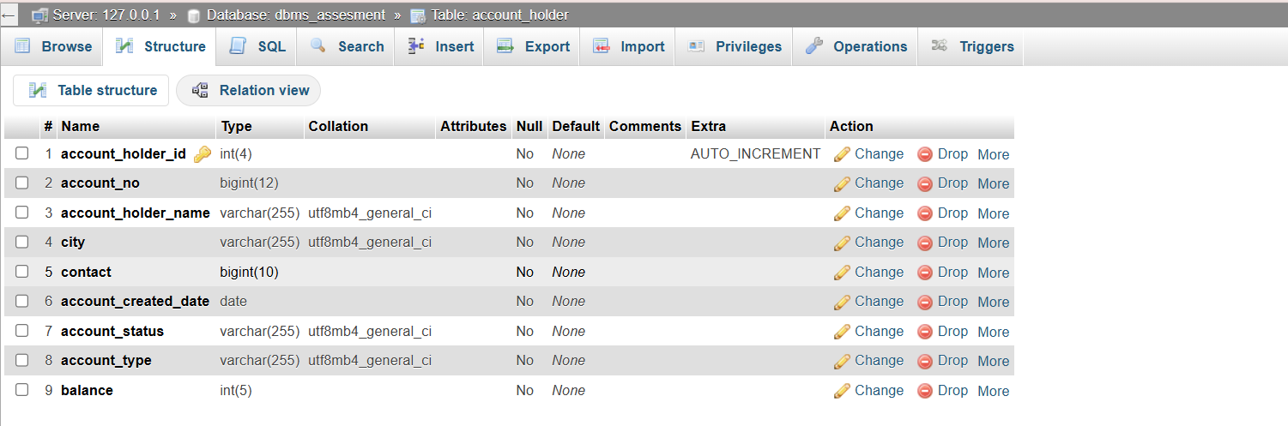

Table created for loan:-

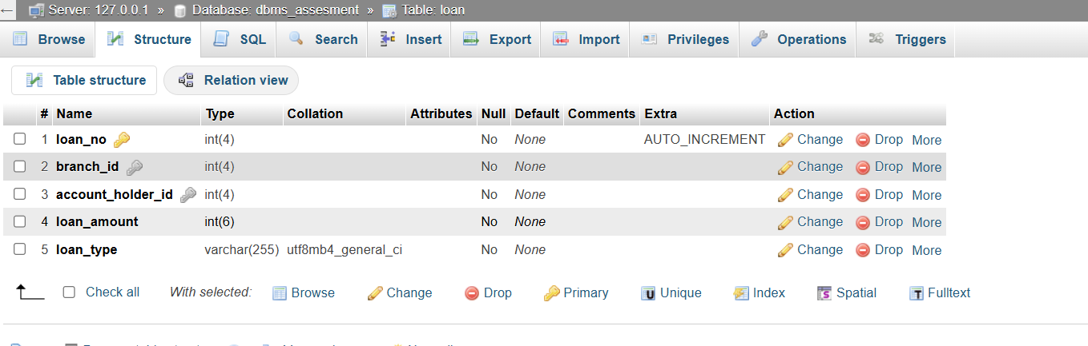

Give Relation of Foreign Key Constraint to branch_id and account_holder_id:-

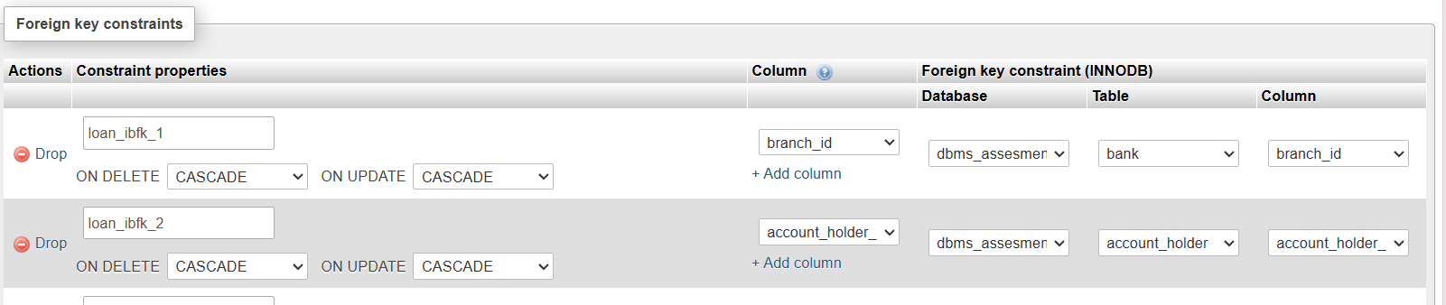

* Insert data in account_holder table for begin the transaction
* INSERT INTO `account_holder` (`account_holder_id`, `account_no`, `account_holder_name`, `city`, `contact`, `date_of_account_created`, `account_status`, `account_type`, `balance`) VALUES
* (1, 1234561, 'ABC', 'Ahmedabad', '7895874589', '2024-12-11', 'Active', 'Current', 1000.00),
* (2, 1234562, 'EFG', 'Surat', '8968236541', '2024-12-10', 'Active', 'Saving', 1000.00);
* Transfer Funds from Acc1 to Acc2 and update the balance in both account

START TRANSACTION ;

UPDATE account_holder SET balance=balance-100 WHERE account_no=’1234561’;

UPDATE account_holder SET balance=balance+100 WHERE account_no=’1234562’;

COMMIT;

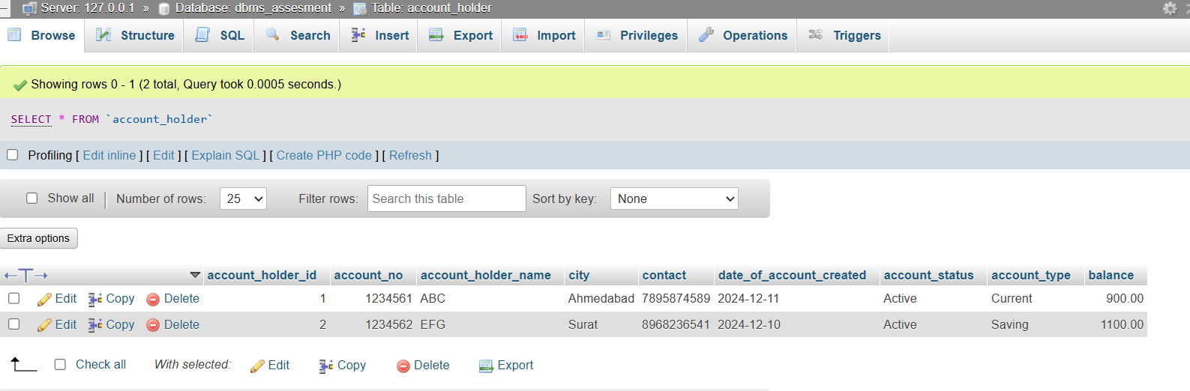

After this balance Updated ..

Data From Same City:- SELECT * FROM `account_holder` WHERE city = "Ahmedabad"

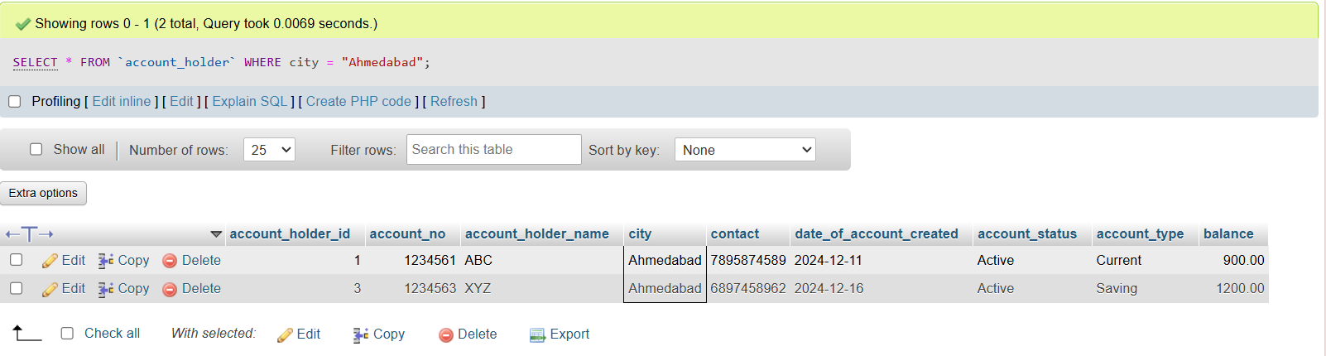

Fetch Account No and Account Holder Name Records where accounts created after the 15th of any month

SELECT account_no , account_holder_name FROM `account_holder` WHERE DAY(date_of_account_created) > 15;

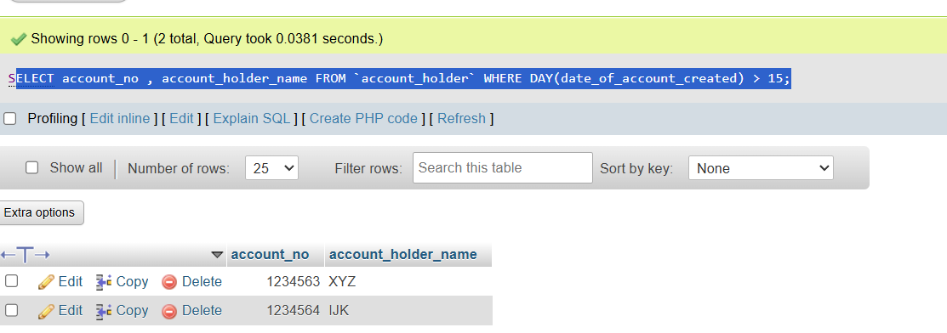

Records to display the city name and count the branches in each city, with the count of branches aliased as Count_Branch

* SELECT branch_city AS City, COUNT(branch_id) AS Count_Branch FROM Bank GROUP BY branch_city;

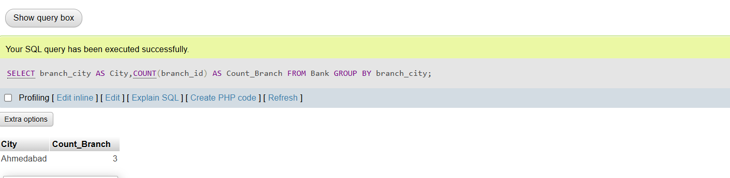

Records to display the account holder’s id, account holder’s name, branch id, and loan amount for people who have taken loans. (NOTE : use sql join concept to solve the query)

* SELECT a.account_holder_id, a.account_holder_name, l.branch_id, l.loan_amount FROM loan l JOIN account_holder a ON l.account_holder_id = a.account_holder_id;

